Table of contents
CONTENTS | PAGE NO
ABSTRACT | i
LIST OF FIGURES | ii
LIST OF TABLES | iii
ACRONYMS | iii
- INTRODUCTION | 1
- Brief Information about the Project | 1
1.2 Motivation and Contribution of Project | 1
1.3 Objectives of the Project | 2
1.4 Scope of the Project | 2
2. SYSTEM ANALYSIS | 3
2.1 Functional Requirements | 3
2.2 Non-Functional Requirements | 3
2.3 Requirements Specification | 4
2.3.1 Minimum Hardware Requirements | 4
2.3.2 Software Requirements | 4
3. TECHNOLOGY DESCRIPTION | 5
3.1 Programming Language | 5
3.1.1 Introduction to Java | 5
3.2 Framework / Libraries | 5
3.2.1 Introduction to Swing | 5
3.3 Database Technology | 6
3.3.1 JDBC (Java Database Connectivity) | 6
3.3.2 MySQL Database | 6
3.4 Tools & IDEs | 7
- Visual Studio Code | 7
4. DATABASE DESIGN | 8
4.1 Database Tables | 8
4.2 Table Structure | 8
4.3 Keys and Constraints | 11
5. SYSTEM DESIGN | 12
5.1 System Architecture | 12
5.2 Modules Description | 12
6. SYSTEM IMPLEMENTATION | 13
7. CONCLUSION | 17
8. FUTURE ENHANCEMENTS | 17
9. REFERENCES | 18
APPENDIX (Sample Code) | 19
APPENDIX (SQL Queries) | 21

ABSTRACT
The Student Result Management System is a desktop-based application developed to manage student academic records in an efficient and organized manner.
The system provides a digital platform for storing, updating, retrieving, and displaying student results using a structured database.
The application is developed using Core Java for programming, Swing for designing the graphical user interface, JDBC for database connectivity, and MySQL for database management.
The system includes modules such as Admin Login, Student Login, Result Management, PDF Report Generation, and Application for Revaluation.
The application reduces manual work, improves data accuracy, and allows quick access to student results.
The system also provides functionality to generate student result reports in PDF format.
This project demonstrates how Java desktop applications can be integrated with databases to build real-world management systems.

LIST OF FIGURES
Figure no. | Figure Title | Page no.
1 | Figure 1: Login Screen of Student Result Management System | 10
2 | Figure 2: Admin Dashboard Screen of Student Result Management System | 10
3 | Figure 3: Analytics Screen for Admin of Student Result Management System | 11
4 | Figure 4: Students Management Screen of Student Result Management System | 11
5 | Figure 5: Adding student and marks in Student Result Management System | 11
6 | Figure 6: Marks Management Screen of Student Result Management System | 12
7 | Figure 7: Student Dashboard Screen of Student Result Management System | 12
8 | Figure 8: Revaluation Screen of Student Result Management System | 13
9 | Figure 9: Student Marksheet Screen of Student Result Management System | 13

LIST OF TABLES
Table no. | Table Title | Page no.
1 | Users Relational Database Table | 8
2 | Students Relational Database Table | 9
3 | Marks Relational Database Table | 9
4 | Student_results Relational Database Table | 10
5 | Notifications Relational Database Table | 10
6 | Revaluation_requests Relational Database Table | 11

ACRONYMS
- SRMS : Student Result Management System
- JDBC : Java Database Connectivity
- GUI : Graphical User Interface
- SQL : Structured Query Language
- PDF : Portable Document Format

- INTRODUCTION

1.1 Brief Information about the Project
The Student Result Management System (SRMS) is a desktop-based application developed to manage student academic performance in a digital format. The system allows administrators to add student details, enter marks, update marks, delete records, and view results. Students can log in using their roll number and name to view their marks and download their result in PDF format. Students can also opt for revaluation if they are not satisfied with obtained marks by paying revaluation fee.
The system is developed using Java Swing for the graphical user interface, JDBC for database connectivity, and MySQL database for storing student data. The system replaces manual result management with a computerized system that improves efficiency, accuracy, and data security.

1.2 Motivation and Contribution of Project
In many colleges and schools, student results are still managed manually using paper records or spreadsheets. This leads to problems such as data loss, calculation errors, and difficulty in searching student records.
This project was developed to solve these problems by creating a digital result management system.
The main contributions of this project include:
- Providing a digital platform for managing student results
- Reducing manual calculation errors
- Providing secure login for admin and students
- Generating student result reports in PDF format
- Allows students to apply for revaluation
- Improving speed and accuracy of result management

  - Objectives of the Project
The main objectives of the Student Result Management System are:
- To develop a user-friendly result management application
- To store student details and marks in a database
- To allow admin to add, update, and delete student results
- To allow students to view their results
- To generate student result reports in PDF format
- To revaluate the student script if requested
- To calculate total marks, average, and final result automatically

  - Scope of the Project
The Student Result Management System can be used in schools and colleges to manage student academic records. The system allows the administrator to manage student data and marks, while students can log in to view and download their results. The system is suitable for small and medium educational institutions.

2. SYSTEM ANALYSIS
2.1 Functional Requirements
Functional requirements define the core operations and functionalities that the Student Result Management System (SRMS) must perform to effectively manage student result-related information. The Functional requirements of Student Result Management System (SRMS)
- Admin Login
- Student Login
- Add Student Details
- Add Student Marks
- Update Student Marks
- Delete Student Record
- View Student Results
- Calculate Total and Average Marks
- Generate Result PDF
- Revaluation of Scripts as Requested
- Search Student by Roll Number
- Display Student Data in Table Format
2.2 Non-Functional Requirements
Non-functional requirements define the quality attributes and performance standards that the Student Result Management System must satisfy.
- Performance
The system should respond quickly when searching and displaying student results.
- Security
Only admin can modify student data. Students can only view their results.
- Usability
The system should have a simple and user-friendly interface.
- Reliability
The system should not lose data and should handle errors properly.
- Scalability
The system should support adding more students and subjects in the future.
2.3 Requirements Specification
This section specifies the hardware and software needed to run the system.
2.3.1 Minimum Hardware Requirements
- Processor: Intel i3 or above
- RAM: 4 GB (minimum)
- Hard Disk: 20 GB free space
- Monitor: Standard display
- Keyboard and Mouse
2.3.2 Software Requirements
- Operating System: Windows 10/11
- Programming Language: Java
- GUI: Swing
- IDE: VS Code
- Database: MySQL Database
- Connectivity: JDBC
- Library: iText PDF Library

3. TECHNOLOGY DESCRIPTION
3.1 Programming Language
3.1.1 Introduction to Java
Java is a high-level, object-oriented programming language developed by Sun Microsystems. It is widely used for developing desktop, web, and enterprise applications due to its platform independence and robustness.
In the Student Result Management System, Java is used to implement the core functionality of the application. It handles operations such as adding, updating, deleting, and searching student marks records. Java provides features like object-oriented programming, exception handling, and strong memory management, which help in building reliable and efficient applications.
One of the main advantages of Java is that it is platform-independent, meaning the program can run on any system that has a Java Virtual Machine (JVM). This makes it suitable for developing portable applications like the Student Result Management System.
3.2 Framework / Libraries
3.2.1 Introduction to Swing
Swing is a part of Java that is used to create graphical user interfaces (GUI). It provides a set of components such as buttons, labels, text fields, tables, and frames to design user-friendly applications.
In this project, Swing is used to design the user interface of the Student Result Management System. It allows users to interact with the system easily through windows such as:
  - Login Screen
  - Admin Dashboard
  - Student Dashboard
  - Marks Entry Form
  - Result Display Table
  - Revaluation Payment & Status
Swing provides flexibility in designing layouts and improves the overall user experience. It makes the application visually interactive and easy to use.

3.3 Database Technology
The Student Result Management System uses a relational database for storing and managing student result related information in a structured manner. The database ensures efficient data storage, retrieval, and manipulation, which is essential for maintaining accuracy and consistency in the system. In this project, MySQL Database is used as the backend, and JDBC is used for connecting the Java application to the database.

3.3.1 JDBC (Java Database Connectivity)
JDBC is an API (Application Programming Interface) used in Java to connect and interact with databases. It allows Java applications to execute SQL queries and retrieve or update data in the database.
In the Student Result Management System, JDBC is used to connect the Java application with the MySQL database. It performs operations such as:
- Establishing a connection to the database
- Executing SQL queries (INSERT, UPDATE, DELETE, SELECT)
- Retrieving data from the database
- Closing the database connection
JDBC acts as a bridge between the application and the database, ensuring smooth communication and data transfer. It helps in maintaining data consistency and enables efficient data handling.
3.3.2 MySQL Database
MySQL Database is a powerful relational database management system used for storing and managing structured data. It provides high performance, reliability, and security for handling large volumes of data.
In the Student Result Management System, MySQL Database is used to store student details such as roll number, name, department, and marks. It supports SQL for data manipulation and ensures data integrity through constraints like primary keys and data types. It ensures structured storage and easy retrieval of student information.

3.4 Tools & IDEs
3.4.1 Visual Studio Code
Visual Studio Code (VS Code) is used as the development environment for the Student Result Management System. It is a lightweight code editor that supports Java programming through extensions. VS Code provides features such as syntax highlighting, code completion, and debugging support, which help improve coding efficiency. It’s simple and user-friendly interface makes it suitable for developing and testing the application.

4. DATABASE DESIGN
4.1 Database Tables
The Student Result Management System uses a relational database to store students’ information in a structured manner. The database consists of two main tables: Users, Student, Marks, Student_results, Notifications, and Revaluation_requests.
- The Users table stores admins’ information i.e., details of the faculty.
- The Student table stores student information and is linked to other tables, like Marks, Student_results etc.
- The Marks table stores marks of the student in each of their subjects.
- The Student_results table is actually a view which gives the details about both the student and their marks list which is useful for result report generation.
- The Notifications table stores the details of the notifications.
- The Revaluation_requests table stores all about the revaluation requests details, and about the revaluation payments.
This separation of data helps in reducing redundancy and improves data organization.

4.2 Table Structure
4.2.1 Users Table

Field Name | Data Type | Description
id | INT | User ID (Primary Key)
username | VARCHAR(100) | Admin Username
password | VARCHAR(100) | Admin Password
role | VARCHAR(20) | Role of the User
Created_at | TIMESTAMP | Account creation  date and time

Table 1: Users Relational Database Table

4.2.2 Students Table

Field Name | Data Type | Description
id | INT | Unique Student ID
roll | VARCHAR(50) | Student Roll Number
name | VARCHAR(50) | Student Name
dept | VARCHAR(200) | Department
email | VARCHAR(200) | Student mail
password | VARCHAR(50) | Student Password
created_at | TIMESTAMP | Student Account Creation Date
Table 2: Students Relational Database Table

4.2.3 Marks Table

Field Name | Data Type | Description
id | INT | Marks ID
student_roll | VARCHAR(50) | Student Roll Number  (Foreign Key)
subject | VARCHAR(100) | Subject Name
marks | INT | Marks
semester | VARCHAR(50) | Semester of the student
exam_date | DATE | Exam date
Table 3: Marks Relational Database Table

4.2.4 Student_results Table

Field Name | Data Type | Description
roll | VARCHAR | Student Roll Number
name | VARCHAR | Student Name
dept | VARCHAR | Student Department
subject | VARCHAR | Subject Name
marks | INT | Marks
semester | VARCHAR | Semester of the student
grade | VARCHAR | Grade calculated  based on marks
Table 4: Student_results Relational Database Table

4.2.5 Revaluation_requests Table

Field Name | Data Type | Description
id | INT | Marks ID
student_roll | VARCHAR(20) | Student Roll Number
student_name | VARCHAR(100) | Student Name
subject | VARCHAR(100) | Subject Name
subject_code | VARCHAR(20) | Subject Code
amount | DECIMAL(10,2) | Revaluation fee amount
payment_method | VARCHAR(50) | Payment method used
reason | TEXT | Reason for revaluation
transaction_id | VARCHAR(100) | Payment transaction ID
Status | VARCHAR(20) | Request Status  (pending/approved/rejected)
request_date | TIMESTAMP | Request submission date
Table 5: Revaluation_requests Relational Database Table

4.2.6 Notifications Table

Field Name | Data Type | Description
id | INT | Notification ID
student_roll | VARCHAR(20) | Student Roll Number
message | TEXT | Notification message
type | VARCHAR(50) | Notification type
is_read | BOOLEAN | Notification read status
created_at | DATE | Notification  date and time
Table 6: Notifications Relational Database Table

4.3 Keys and Constraints
Keys and constraints are used to maintain data integrity and ensure accurate data storage.
- Primary Keys:
  - roll in Students table
  - roll & subject in Marks table
  - username in Users table
- NOT NULL Constraint:
  - Important fields such as roll, name, marks, password and department cannot be left empty
- Data Type Constraints:
- Each field accepts only valid data types to ensure correctness
- These constraints help in maintaining consistency and avoiding duplicate or invalid data.

5. SYSTEM DESIGN
5.1 System Architecture
The Student Result Management System follows a three-layer architecture:
- Presentation Layer (User Interface)
  - Developed using Java Swing
  - Allows users to interact with the system
- Application Layer (Business Logic)
  - Processes user inputs
  - Performs operations like add, update, delete, search
- Data Layer (Database)
  - Stores students and marks data
  - Managed using MySQL Database
This architecture ensures better organization, security, and maintainability.
5.2 Modules Description
The system is divided into the following modules:
1. Admin Module
- Adds new student details
- Updates existing records of marks
- Deletes student data
- Shows student marks’ data in table format
2. Login Module
- Handles Admin and Student login
- Enters into their designated dashboards
3. Student Module
- Students can view their results
4. Result Calculation Module
- Calculates total, average and pass/fail for each student
- Calculates average, highest, lowest, pass percentage of all students
5. PDF Generation Module
- Generates result report in PDF format
6. Database Module
- Handles database connectivity using JDBC

6. SYSTEM IMPLEMENTATION
Login Screen:
Displays the login interface where the user enters username and password.

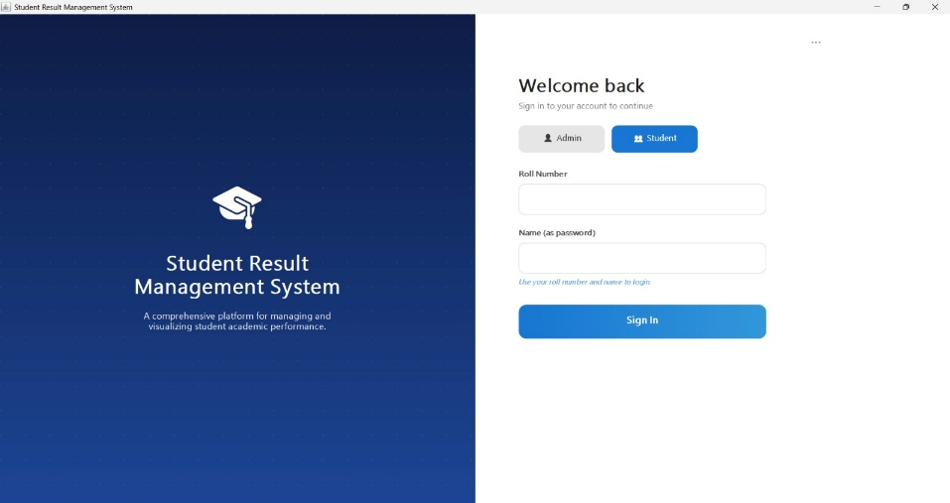
Figure 1: Login Screen of Student Result Management System

Admin Dashboard Screen:

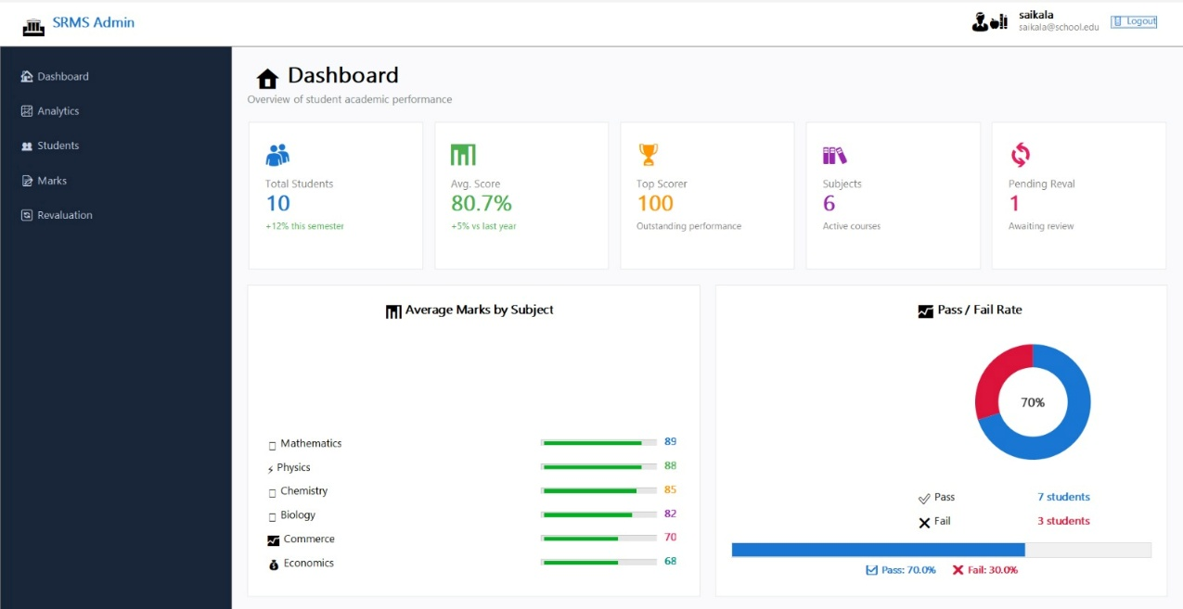
Figure 2: Admin Dashboard Screen of Student Result Management System

Analytics in Admin Screen:
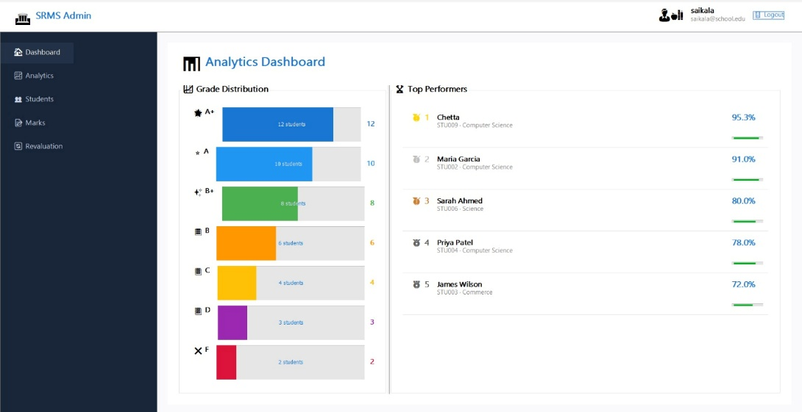
Figure 3: Analytics Screen for Admin of Student Result Management System
Students’ List Screen:
Displays the interface for adding, modifying, and deleting student details.
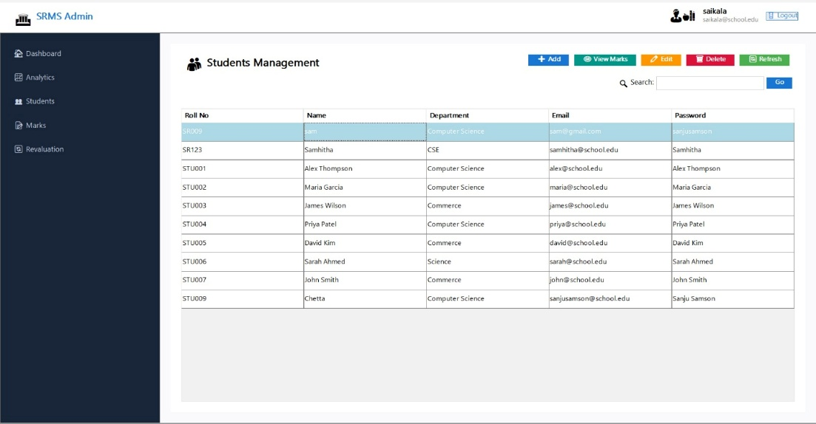
Figure 4: Students Management Screen of Student Result Management System

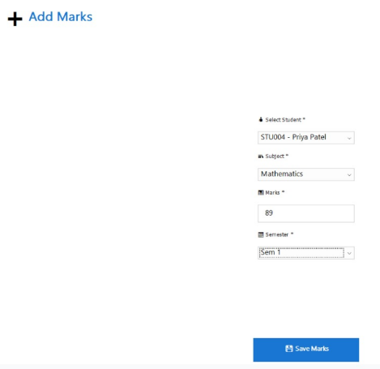
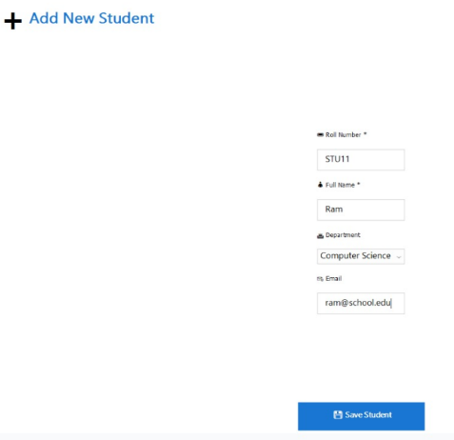

Figure 5: Adding student and marks in Student Result Management System
Marks’ List Screen
Displays all student’s marks records in a table format where the admin can add, modify, and delete students’ marks.

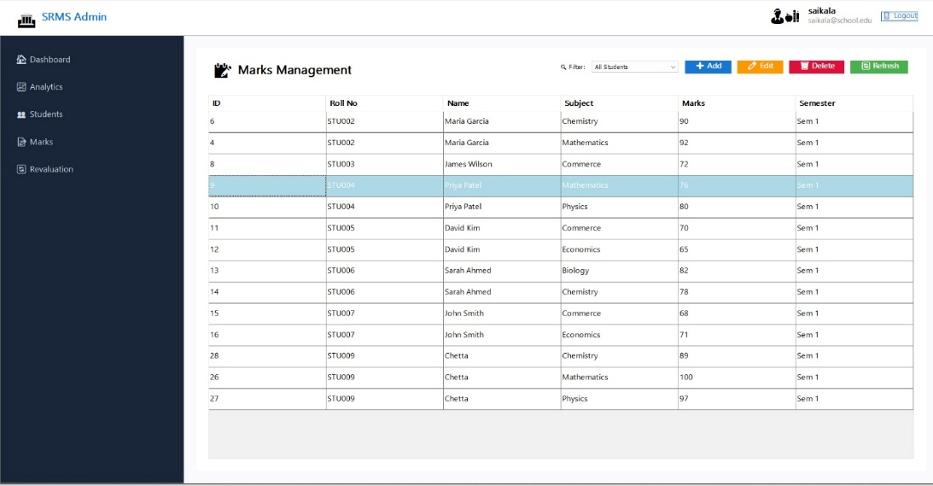
Figure 6: Marks Management Screen of Student Result Management System
Student Dashboard Screen
Shows the interface of the student.

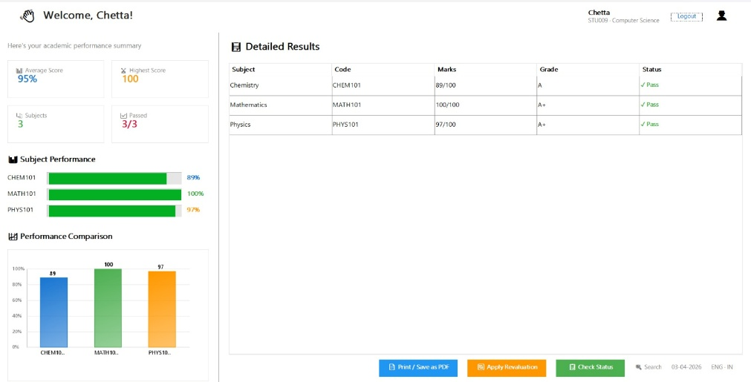
Figure 7: Student Dashboard Screen of Student Result Management System

Revaluation Application & Status Screen
Shows the revaluation payment process and status.
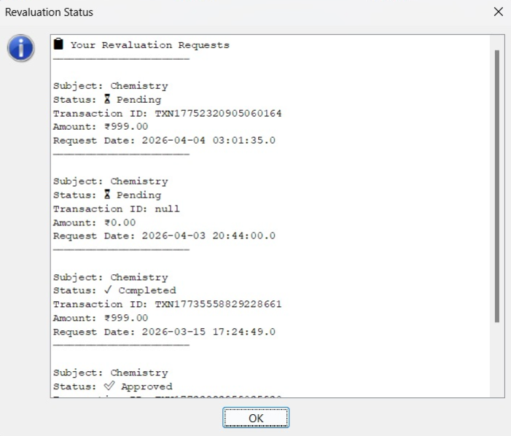
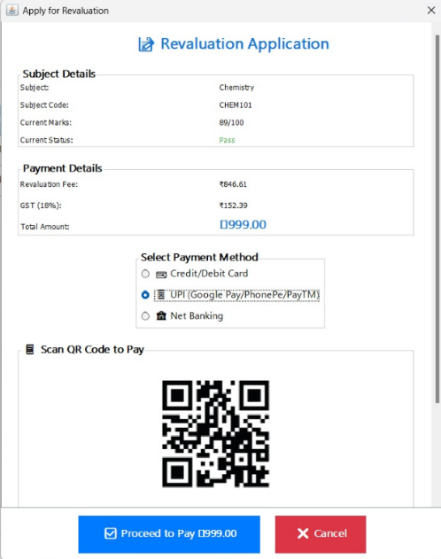

Figure 8: Revaluation Screen of Student Result Management System

Student Marksheet Screen
Shows the student marksheet in a table format along with grade and pass/fail.
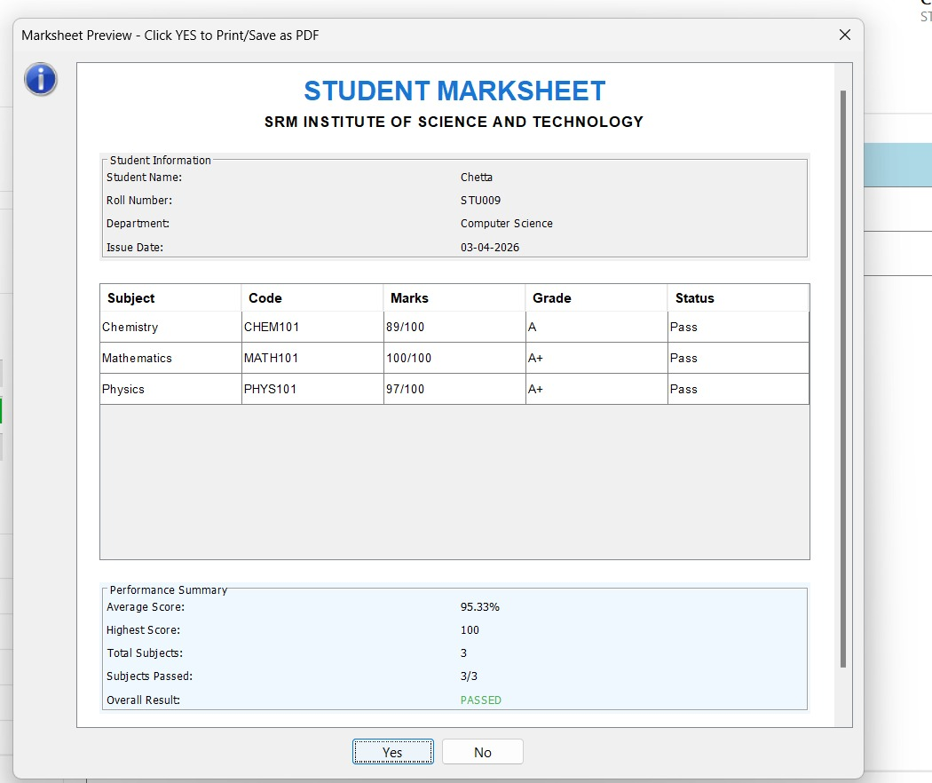

Figure 9: Student Marksheet Screen of Student Result Management System

7. CONCLUSION
The Student Result Management System was successfully developed using Java Swing and MySQL database.
The system provides a simple and efficient way to manage student results digitally. It reduces manual work, improves accuracy, and allows quick access to student results.
The system includes important features such as admin login, student login, result management, automatic result calculation, and PDF report generation.
The project demonstrates how Java can be used to develop real-world desktop applications with database connectivity.

8. FUTURE ENHANCEMENTS
The Student Management System developed in this project provides basic functionalities for managing student’s result records. However, the system can be further enhanced by adding advanced features to improve its functionality and usability.
Some possible future enhancements include:
- Student Attendance Management:
Integrating attendance tracking and presence percentage management
- Web-Based Application:
Converting the desktop application into a web-based system for remote access
- Multi-Admin Login Support:
Allowing multiple users to access the system simultaneously
- Sending Results via Email:
Without the hassle of downloading from the website, student can directly get the results sent to their emails.
- Improved User Interface:
Enhancing the design for better user experience
These enhancements can make the system more scalable, secure, and suitable for real-time organizational use.

9. REFERENCES
The following references were used during the development of the Student Result Management System:
- E. Balagurusamy, Programming with Java, McGraw Hill Education.
- Korth, Silberschatz, Sudarshan, Database System Concepts, McGraw Hill.
- MySQL Documentation,
https://docs.mysql.com
- Java Documentation (MySQL),
https://docs.mysql.com/javase
- JDBC Tutorial – GeeksforGeeks,
https://www.geeksforgeeks.org/jdbc/
- Java Swing Tutorial – TutorialsPoint,
https://www.tutorialspoint.com/java_swing
- W3Schools Java Tutorial,
https://www.w3schools.com/java/
- iText PDF Documentation
https://itextpdf..com/resources/api-documentation

APPENDIX
A.1 Sample Code

Database Connection Code:
The following code establishes a connection between the Java application and the MySQL database using JDBC.
DBConnection.java:
import java.sql.*;
public class DBConnection {
public static Connection getConnection() {
Connection con = null;
try {
Class.forName("com.mysql.cj.jdbc.Driver");
String url = "jdbc:mysql://localhost:3306/studentdb?useSSL=false&serverTimezone=UTC";
con = DriverManager.getConnection(url, "root", "root");
} catch (Exception e) {
System.out.println(e);
}
return con;
}
}

Insert Student Record:
This code is used to add a new student into the database.
InsertStudent.java:
import java.sql.*;
public class InsertStudent {
public static void main(String[] args) {
try {
Connection con = DBConnection.getConnection();
String roll = rollField.getText().trim();
String name = nameField.getText().trim();
String dept = (String) deptCombo.getSelectedItem();
String email = emailField.getText().trim();

if (roll.isEmpty() || name.isEmpty()) {
JOptionPane.showMessageDialog(this, "Roll Number and Name are required!");
return;
}

String query = "INSERT INTO students (roll, name, dept, email, password) VALUES (?, ?, ?, ?, ?)";
PreparedStatement pst = con.prepareStatement(query);
pst.setString(1, roll);
pst.setString(2, name);
pst.setString(3, dept);
pst.setString(4, email.isEmpty() ? name.toLowerCase() + "@school.edu" : email);
pst.setString(5, name);

int result = pst.executeUpdate();
if (result > 0) {
JOptionPane.showMessageDialog(this, "✅ Student added successfully!");
con.close();
} catch (Exception e) {
System.out.println(e);
}
}
}

A.2 SQL Queries
Create Users Table:
CREATE TABLE users (
id INT AUTO_INCREMENT PRIMARY KEY,
username VARCHAR(100) NOT NULL,
password VARCHAR(100) NOT NULL,
role VARCHAR(20) DEFAULT 'admin',
created_at TIMESTAMP DEFAULT CURRENT_TIMESTAMP );
Create Students Table:
CREATE TABLE students (
id INT AUTO_INCREMENT PRIMARY KEY,
roll VARCHAR(50) UNIQUE NOT NULL,
name VARCHAR(200) NOT NULL,
dept VARCHAR(100), email VARCHAR(100),
password VARCHAR(100),
created_at TIMESTAMP DEFAULT CURRENT_TIMESTAMP
);
Create Marks Table:
CREATE TABLE marks (
id INT AUTO_INCREMENT PRIMARY KEY,
student_roll VARCHAR(50) NOT NULL,
subject VARCHAR(100) NOT NULL,
marks INT NOT NULL,
semester VARCHAR(50),
exam_date DATE,
FOREIGN KEY (student_roll) REFERENCES students(roll) ON DELETE CASCADE
);

Create Revaluation_requests Table:
CREATE TABLE IF NOT EXISTS revaluation_requests (
id INT AUTO_INCREMENT PRIMARY KEY,
student_roll VARCHAR(20) NOT NULL,
student_name VARCHAR(100) NOT NULL,
subject VARCHAR(100) NOT NULL,
subject_code VARCHAR(20),
amount DECIMAL(10,2),
payment_method VARCHAR(50),
reason TEXT,
transaction_id VARCHAR(100),
status VARCHAR(20) DEFAULT 'Pending',
request_date TIMESTAMP DEFAULT CURRENT_TIMESTAMP,
FOREIGN KEY (student_roll) REFERENCES students(roll)
);
Create Student_results View:
CREATE VIEW student_results AS
SELECT s.roll, s.name, s.dept, m.subject, m.marks, m.semester,
CASE
WHEN m.marks >= 90 THEN 'A+'
WHEN m.marks >= 80 THEN 'A'
WHEN m.marks >= 70 THEN 'B+'
WHEN m.marks >= 60 THEN 'B'
WHEN m.marks >= 50 THEN 'C'
WHEN m.marks >= 40 THEN 'D'
ELSE 'F' END as grade
FROM students s JOIN marks m
ON s.roll = m.student_roll;

Create Notifications Table:
CREATE TABLE IF NOT EXISTS notifications (
id INT AUTO_INCREMENT PRIMARY KEY,
student_roll VARCHAR(20),
message TEXT,
type VARCHAR(50),
is_read BOOLEAN DEFAULT FALSE,
created_at TIMESTAMP DEFAULT CURRENT_TIMESTAMP,
FOREIGN KEY (student_roll) REFERENCES students(roll)
);

